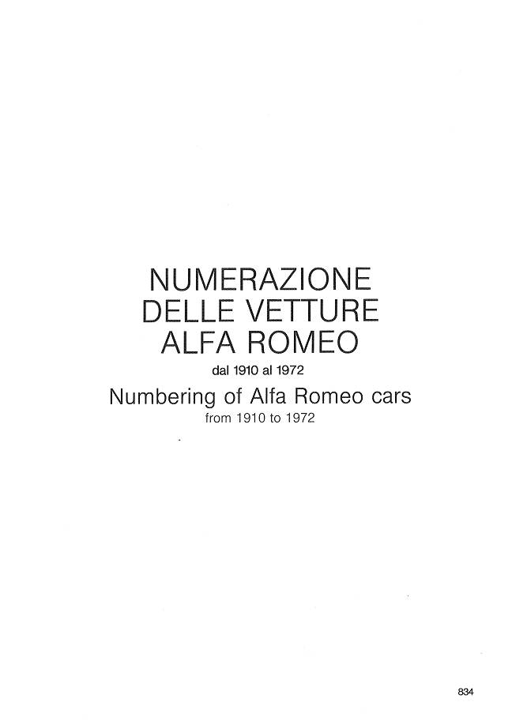

## Originally posted on the AlfaBB by “tubut”.

Note: Fusi's book seems to have a number of errors. A better way to find out about your car is contacting the Alfa Romeo Historical Archive. On the home page of <http://www.archiviostorico.alfaromeo.it> is a hidden link under the word ENGLISH (near the top of the page, next to the round Alfa logo) that switches part of the web site to English.  
  
Once you log in, you can manage your personal profile (password and newsletter settings) and send requests to Alfa. The hoaky thing about the web site is that these menues are partially in Italian -- even on the English parts of the web site. For instance, the "Send Request" menu option leads to a page with the title "Desidero contattarvi per:" (which loosely translates to "I wish to contact you for:"), followed by menu options. If you click on the drop-down box, you see a problem with web design consistency. I don't understand why the designers chose these labels to be in Italian instead of English.  
FWIW, the options translate as follows:

* Informazioni e curiosità --> Information and curiosity (i.e. the newsletter subscription).
* Consulenza sulla mia auto d'epoca --> Consultation about my classic car (asking for model, year and chassis number).
* Richiedere un appuntamento --> Request an appointment (asking for reason and preferred date and time).

Depending on the selection and session state, you may be led to an English page (success) or Italian page (errors or login request).

